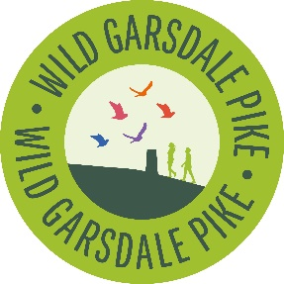
Youth Steering Group Application Form
Name:
Date of Birth:
Address:
Email:
Phone:
Parent/Carer Contact (If under 18yrs) Next of kin (if over 18yrs)
Name:
Phone: Email:

School/College/University/Workplace:

Why do you want to join WGP Youth Steering Group? (150 words max)

What does nature and wildlife conservation mean to you? (150 words max)

What three words best describe you?

What three things in nature mean the most to you?

What can you bring to the group?

What do you hope the group will give you?

What Interests You the Most? (Tick all that you like)
- Data collection & Analysis – surveys & monitoring ( )
- Species (plants, animals, birds, insects etc) ( )
- Wildlife Photography and Film Making ( )
- Blanket Bogs and Wetlands ( )
- Wildflower Meadows ( )
- Tree Planting and Woodland Creation ( )
- Drystone Walling ( )
- Archaeology and Traditional Buildings ( )
- Community Engagement ( )
- Public Speaking and Presenting ( )
- Finance and Funding ( )
- Anything else you’re excited by and interested in – please list ….

Please return by email to info@wildgarsdalepike.org.uk
Thank you!

http://wildgarsdalepike.org.uk/
Follow us on Instagram: wild_garsdalepike

Data protection statement
All the information collected in this form is necessary and relevant to your application to join our Youth Steering Group. We will use the information provided by you on this form to contact you in relation to Youth Steering Group and wider WGP activities. Wild Garsdale Pike will treat all personal information with the utmost confidentiality and in line with current data protection legislation. You may withdraw your consent at any time.
For more information on how we use and store the information you have provided, please see the privacy notice on our website http://wildgarsdalepike.org.uk/privacy-policy or send us a request by email or post.
Wild Garsdale Pike, Room B8, Low Nook, University of Cumbria, Rydal Road, Ambleside, LA22, 9BB

